G. Rupa Manasa 08-12-2023

Day 5 Assessment

* Implementing Equi join and non equi join
* Implementing exists command

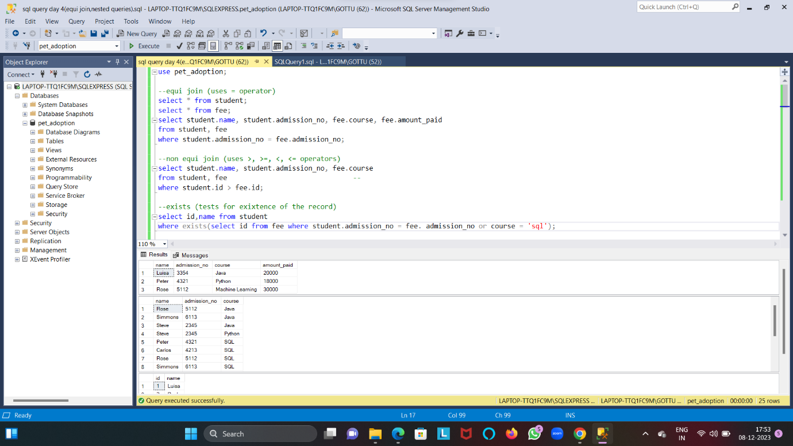

* Implementing ANY command

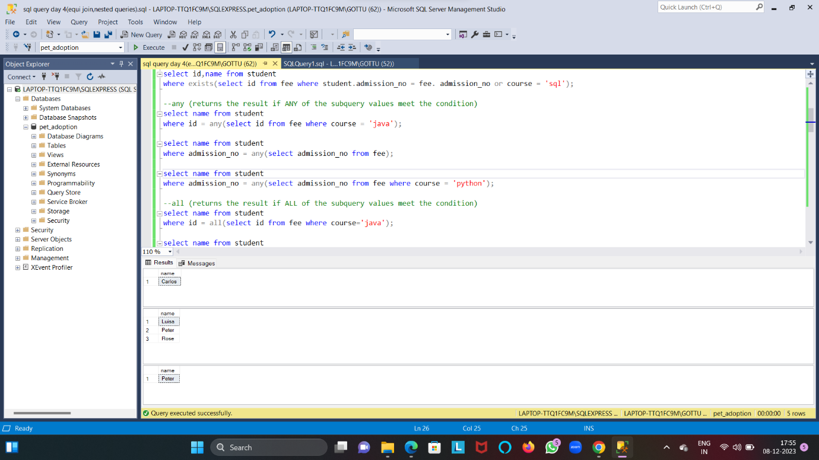

* Implementing ALL command

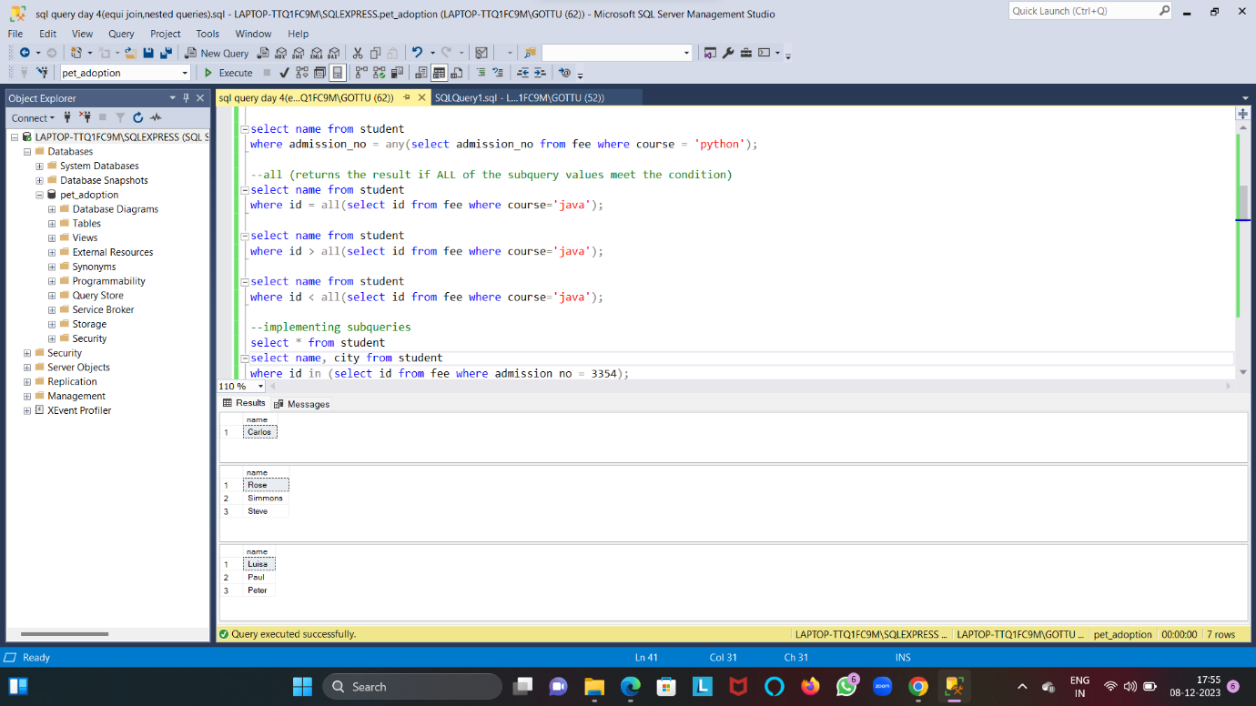

* Implementing sub queries (inserting, deleting and updating using sub queries)

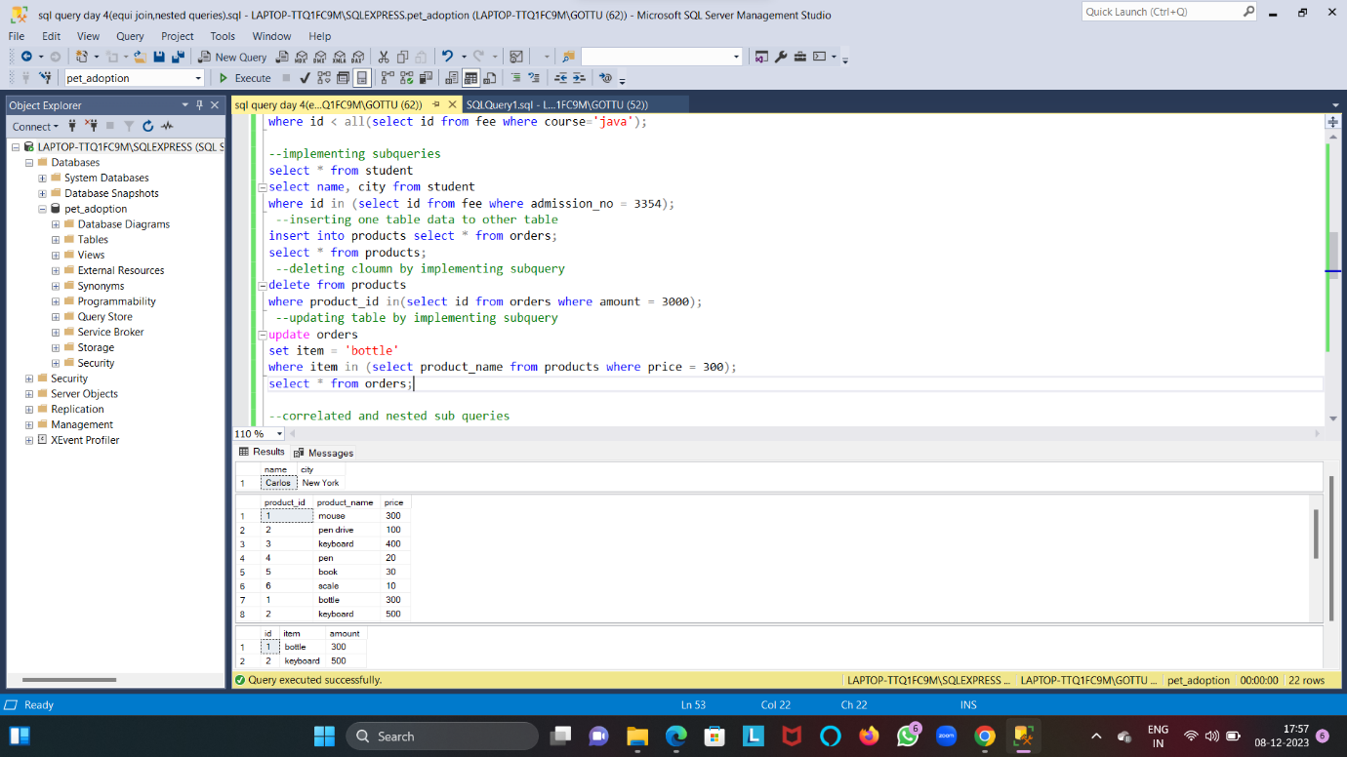

* Implementing correlated subqueries and nested subqueries

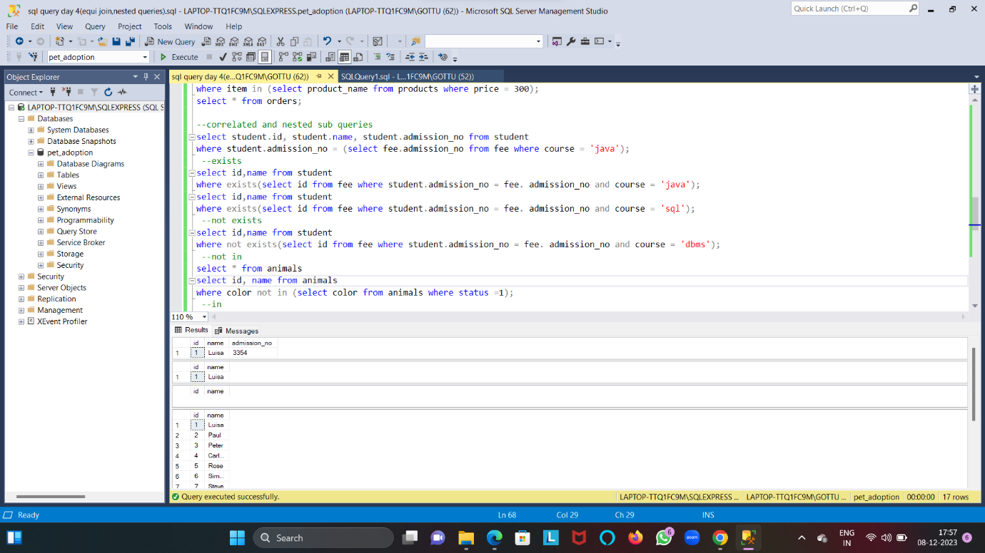

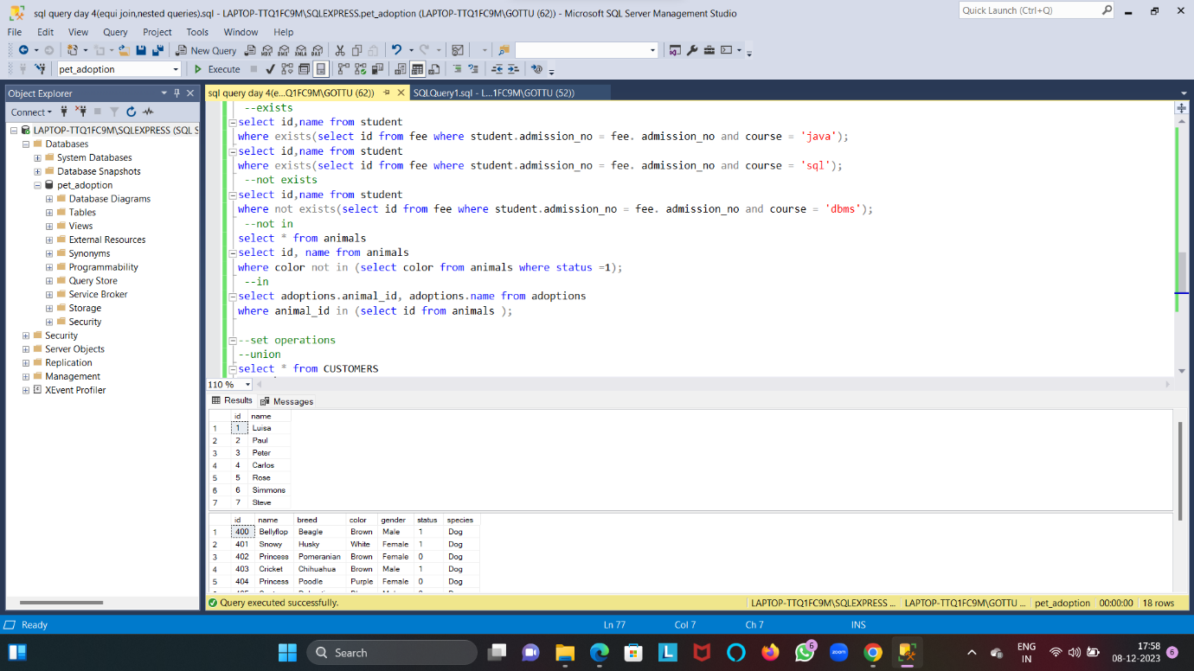

* Implementing UNION, UNION ALL, INTERSECT and EXCEPT

